**EXISTING SYSTEM:**

Cybercrime has undergone a revolutionary change, going from being product-oriented to service-oriented because the fact it operates in the virtual world, with different spatial and temporal constraints, differentiates it from other crime taking place in the physical world. As part of this change, the cybercrime underground has emerged as a secret cybercrime marketplace because emerging technological changes have provided organized cybercriminal groups with unprecedented opportunities for exploitation. The cybercrime underground has a highly professional business model that supports its own underground economy. This business model, known as CaaS, is “a business model used in the underground market where illegal services are provided to help underground buyers conduct cybercrimes, such as attacks, infections, and money laundering in an automated manner,”. Thus, CaaS is referred to as a do-it-for-me service, unlike crimeware which is a do-it-yourself product. Because CaaS is designed for novices, its customers do not need to run a hacking server or have high-level hacking skills. Consequently, the CaaS business model can involve the following roles: writing a hacking program, performing an attack, commissioning an attack, providing an attack server (infrastructure), and laundering the proceeds. Sood and Enbody have suggested that crimeware marketplaces have three key elements, namely actors (e.g., coders, operators, or buyers), value chains, and modes of operation (e.g., CaaS, pay-per-install, crimeware toolkits, brokerage, or supplying data). Periodic monitoring and analysis of the content of cybercrime marketplaces could help predict future cyber threats.

.

**DISADVANTAGES:**

* It is not secured process.
* Over under traction is invents
* Download files, time is invited

**PROPOSED SYSTEM:**

The goal of our data analysis framework is to conduct a big-picture investigation of the cybercrime underground by covering all phases of data analysis from the beginning to the end. This framework comprises four steps: (1) defining goals; (2) identifying sources; (3) selecting analytical methods; and (4) implementing an application. Because this study emphasizes the importance of RAT for analyzing the cybercrime underground, the proposed RAT-based definitions are critical to this framework: Steps 1–4 all contain the RAT elements A. **Step 1:** Defining Goals The first step is to identify the conceptual scope of the analysis. Specifically, this step identifies the analysis context, namely the objectives and goals. To gain an in-depth understanding of the current CaaS research, we investigated the cybercrime underground, which operates as a closed community. Thus, the goal of the proposed framework is to “investigate the cybercrime underground economy.” B. **Step 2:** Identifying Sources the second step is to identify the data sources, based on the goals defined by Step 1. This step should consider what data is needed and where it can be obtained. Since the goal of this study is to investigate the cybercrime underground, we consider data on the cybercrime underground community. We therefore collected such data from the community itself and obtained a malware database from a leading global cyber security research firm. Because cybercriminals often change their IP addresses and use anti-crawling scripts to conceal their communications, we used a self-developed crawler that can resolve captchas and anti-crawling scripts to gather the necessary data. We collected a total of 2,672,091 posts selling CaaS or crimeware, made between August 2008 and October 2017, from a large hacking community site (www.hackforums.net) with over 578,000 members and more than 40 million posts. We also collected 16,172 user profiles of sellers and potential buyers, based on their communication histories, as well as prices and questions and answers about the transactions. The black market uses traditional forum threads (e.g., bulletin boards) instead of typical e-commerce platforms (e.g., eBay, and Amazon). For example, sellers create threads in marketplace forums to sell items, and potential buyers comment on these threads. One of the most significant challenges was therefore converting this unstructured data into structured data. Since the product features, prices, and descriptions were explained within longer texts, we used a variety of text mining techniques to extract the important features: for example, we used named entity recognition to extract company names (see Section IV-C(2)). Since these texts included many typographic errors and jargon terms, we had to create a dictionary for use during a preprocessing step. In addition, we obtained a malware database from a cybersecurity firm containing over 53,815 entries covering cybercrimes between May 11, 2010 and January 13, 2014. This unique dataset strengthened our study by providing real-world evidence from a different viewpoint.

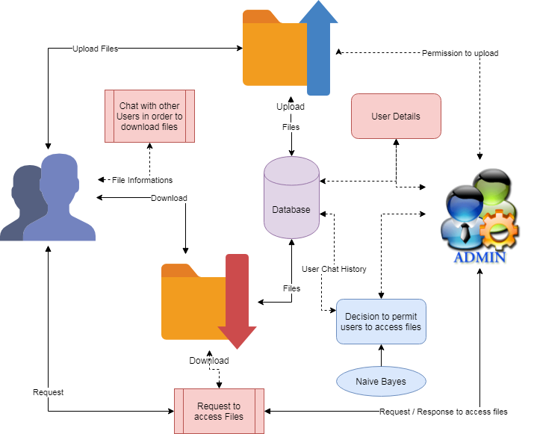

**ADVANTAGES**

* Compelling and relevant content will grab the attention of potential customers and increase brand visibility
* You can respond instantly to industry developments and be seen as ‘thought leader’ or expert in your field. This can improve how your business is seen by your audience.
* Positive feedback is public and can be persuasive to other potential customers.
* Negative feedback highlights areas where you can improve.